Instruction:
Complete all questions in 2 hour.
Group: A
- Unit of computer capable of performing arithmetic, logical and data manipulation operation on binary numbers is called
  - CU
  - ALU ✓
  - I/O units
  - Processing Unit

- Arithmetic logic unit
I. perform arithmetic operations
II. store data
III. perform comparison
IV. communicate with input devices
From above Correct one is.
  - I only
  - II only
  - I and II only
  - I and III only ✓

- Which of the following is component of ALU?
  - Functional Unit
  - Multiplexor
  - Instruction Decoder
  - All of the Above ✓

- Operations of Computer Arithmetic and logic unit is directed by
  - ALU itself
  - Program
  - Control Unit ✓
  - Memory Unit

- An arithmetic logic unit (ALU) is a ______________ digital electronic circuit.
  - Combinational ✓
  - Sequential
  - Both
  - None of above

- Engineering design of arithmetic logic unit determines the
  - Type and number of storing operations
  - Type and number of logical operations
  - Type and number of control operations
  - Type and number of logical and arithmetic operations ✓
- Which is the function of Decoder?
  - Perform logic and arithmetic operation
  - Selects the output we want from ALU ✓
  - Send output choice made through the decoder
  - None of the above

- Which of the following is the function of Multiplexor?
  - Perform logic and arithmetic operation
  - Selects the output we want from ALU
  - Send output choice made through the decoder ✓
  - None of the above

- Both addition and subtraction can be performed by a single circuit using ____________
  - Multiplexor
  - Controlled Inversion ✓
  - Half Adder
  - Fuller Adder

Group B

- Design a combinational Logic circuit that selects and generates any of the following logic and arithmetic functions listed below.
A XOR B
A NOR B
A + B
A – B
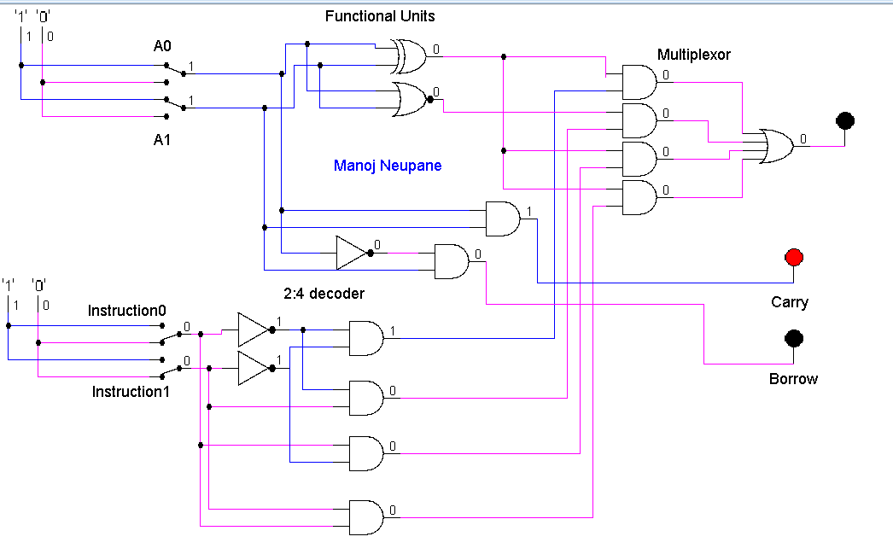

- Design a digital circuit that performs the four logical operations of exclusive-OR, NOR, NAND and OR. Use two selection variables. Show the logic diagram of one typical stage. Discuss the working mechanism of the circuit that you have constructed.
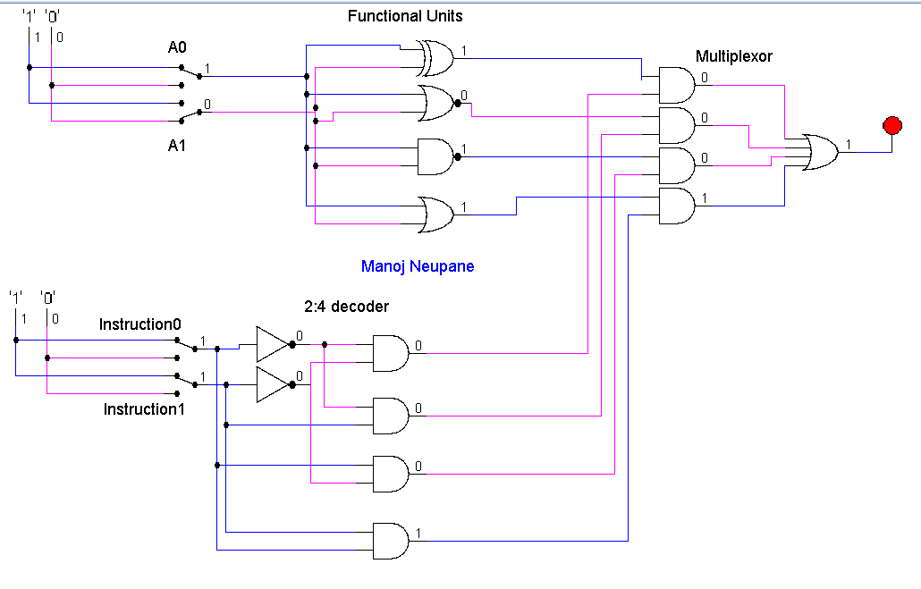

- Following diagram shows a 4 bit adder/subtractor. Design the circuit diagram using Logsim. Discuss how the circuit performs addition and subtraction.
